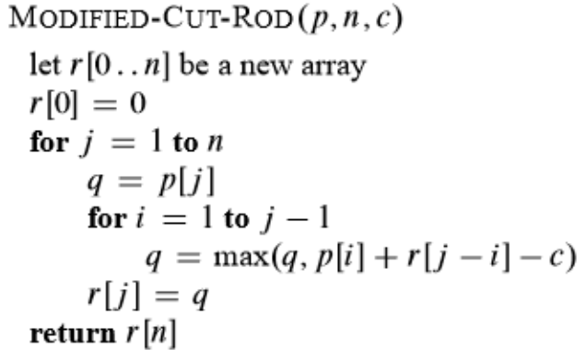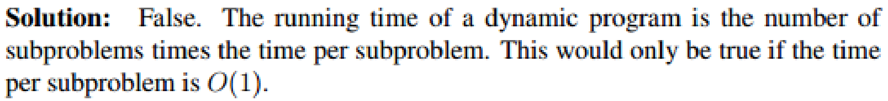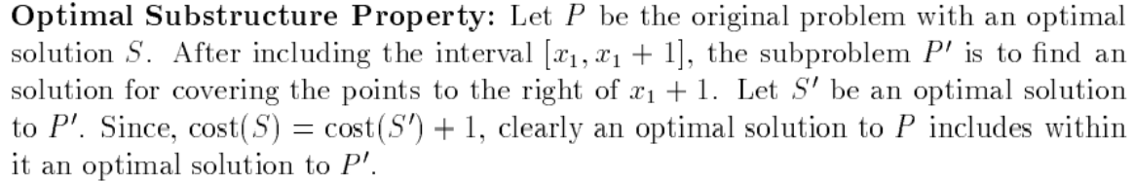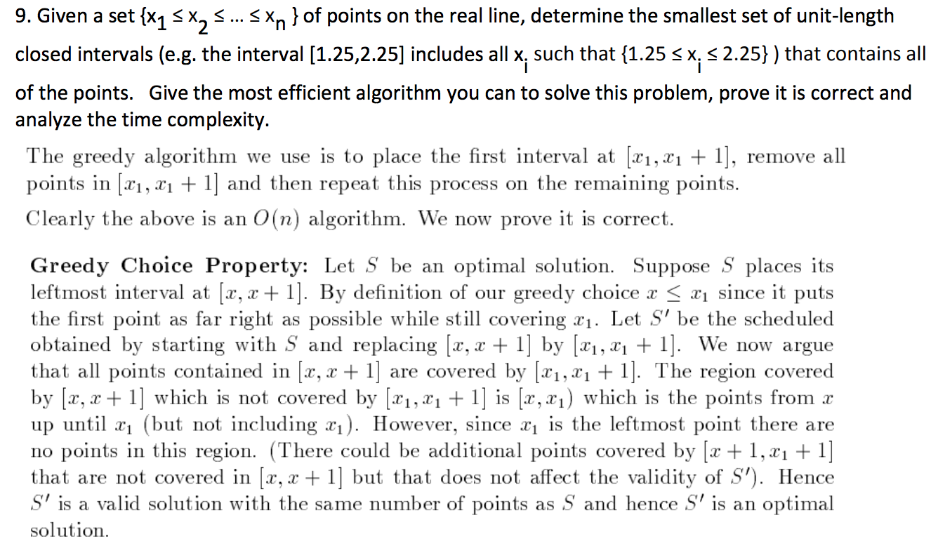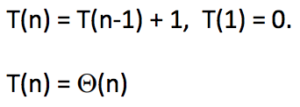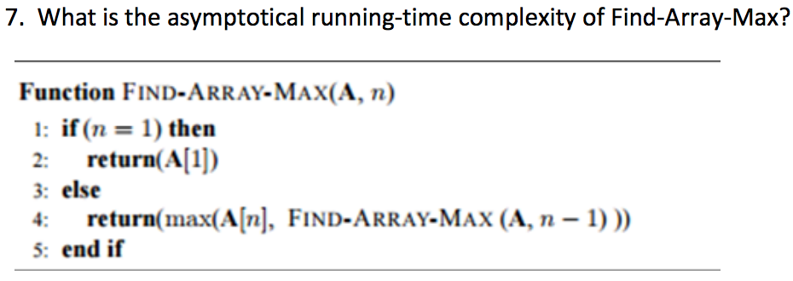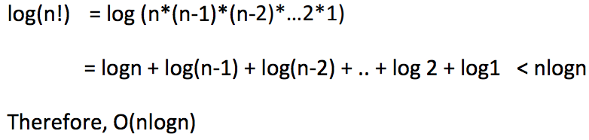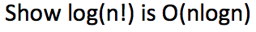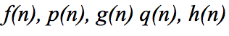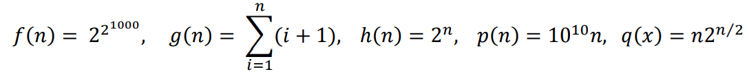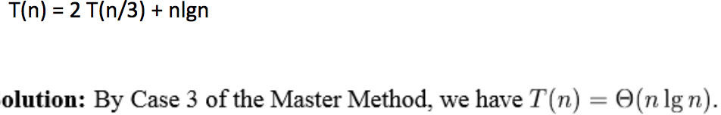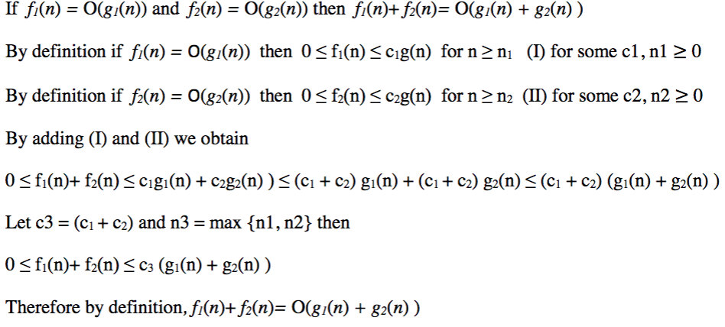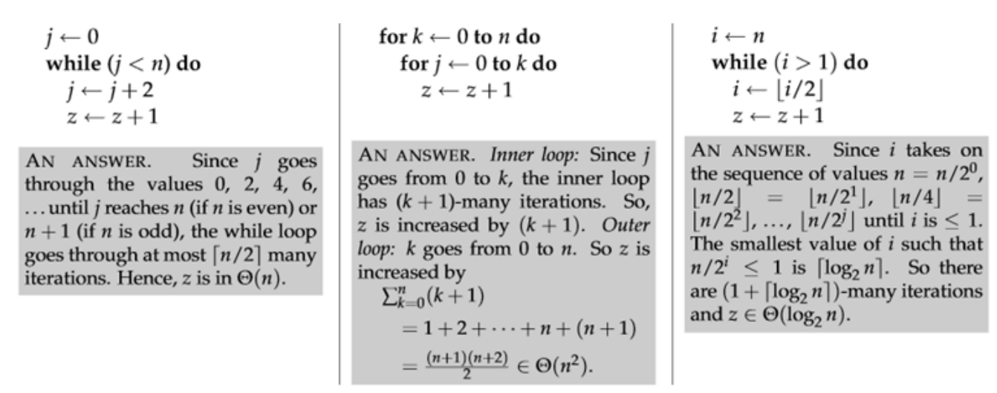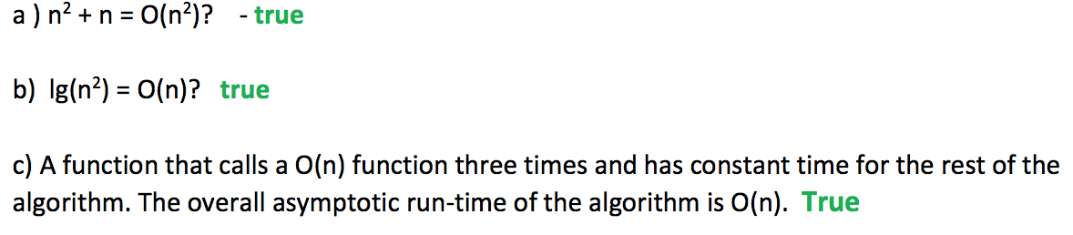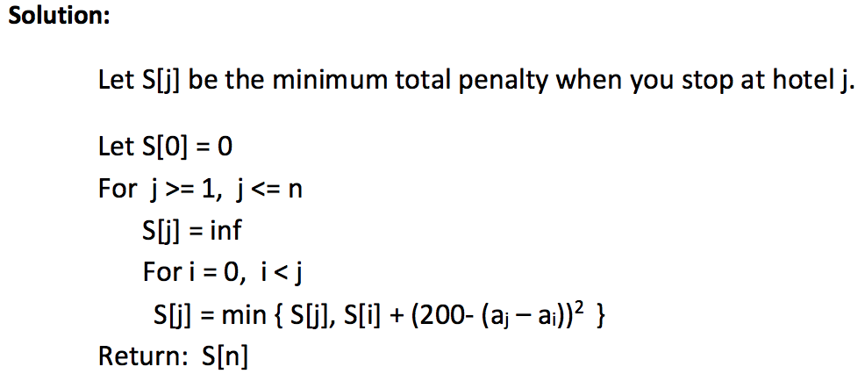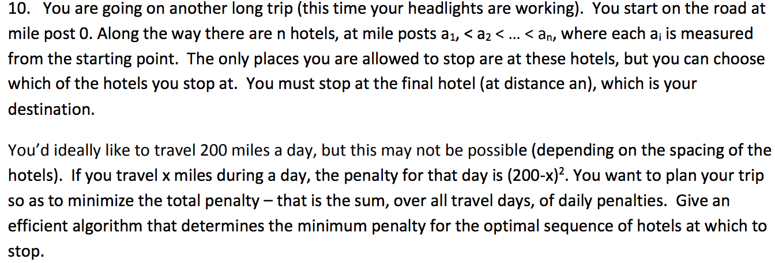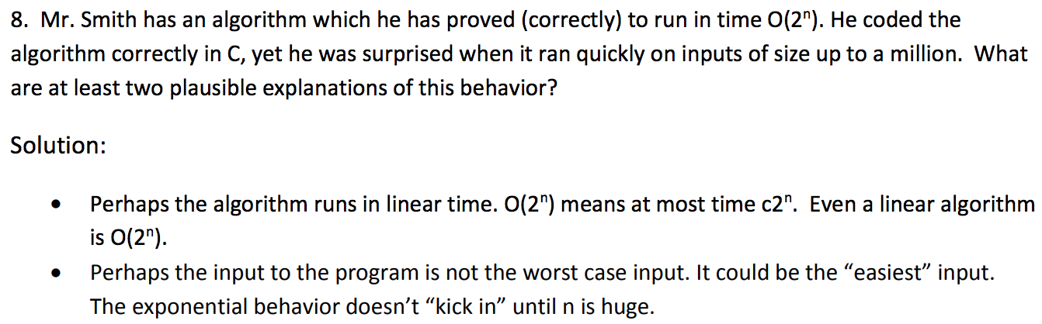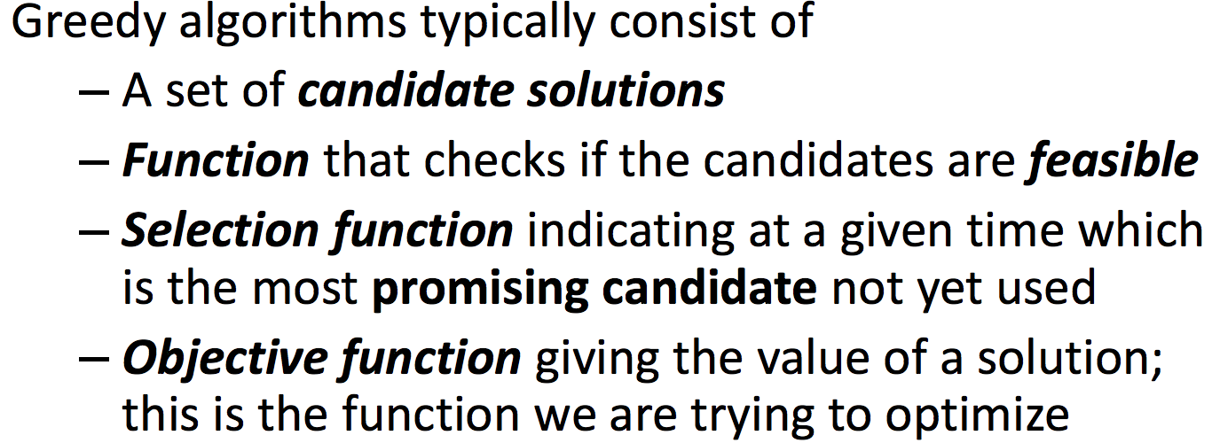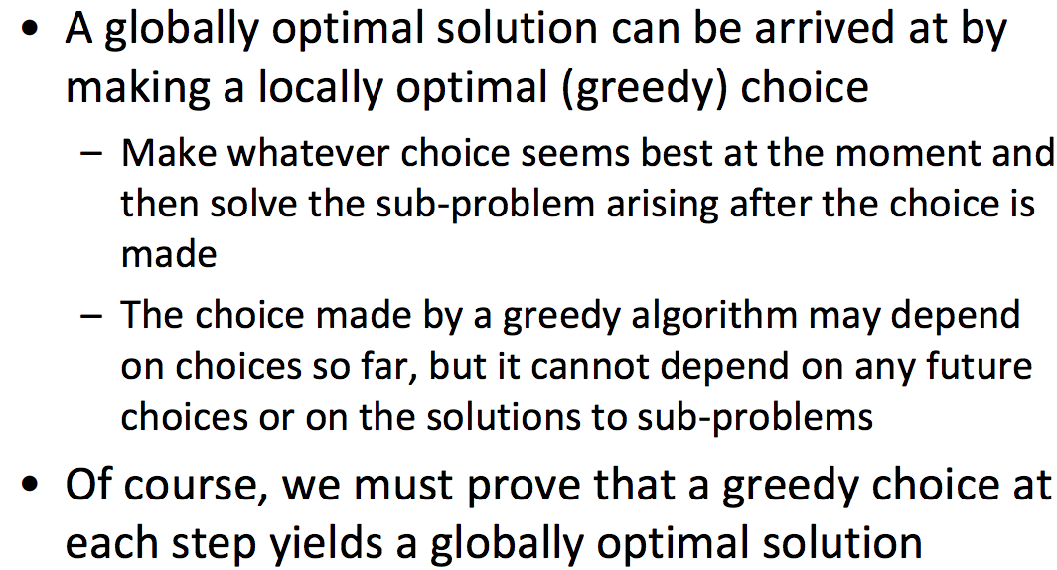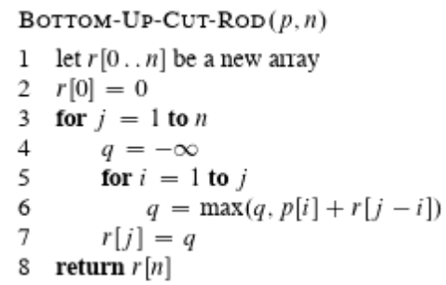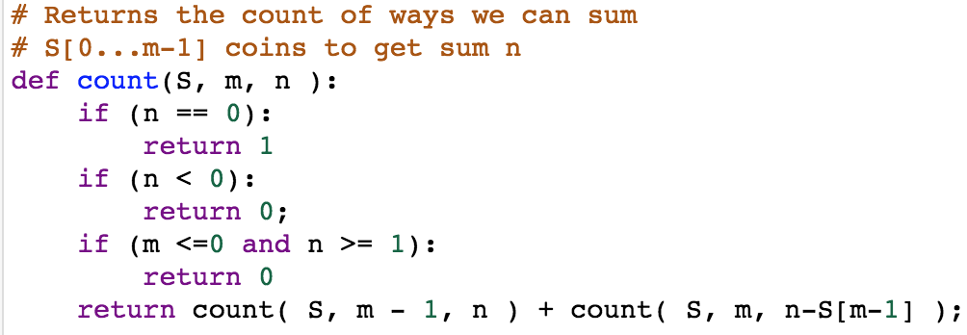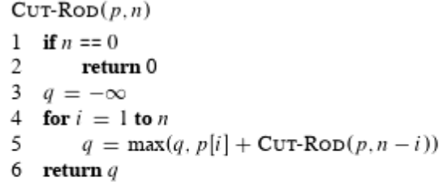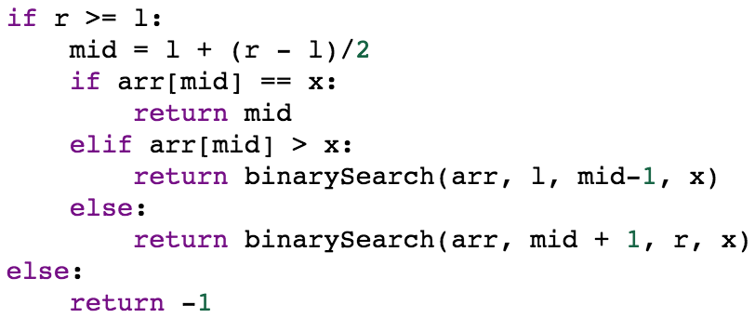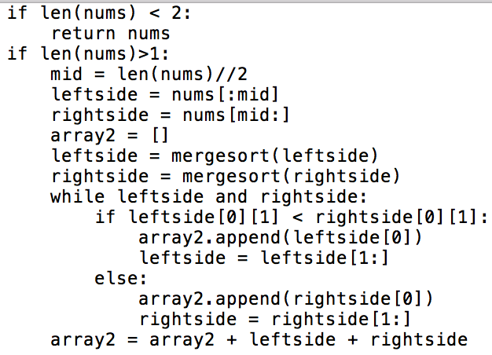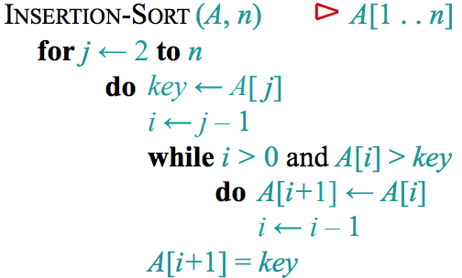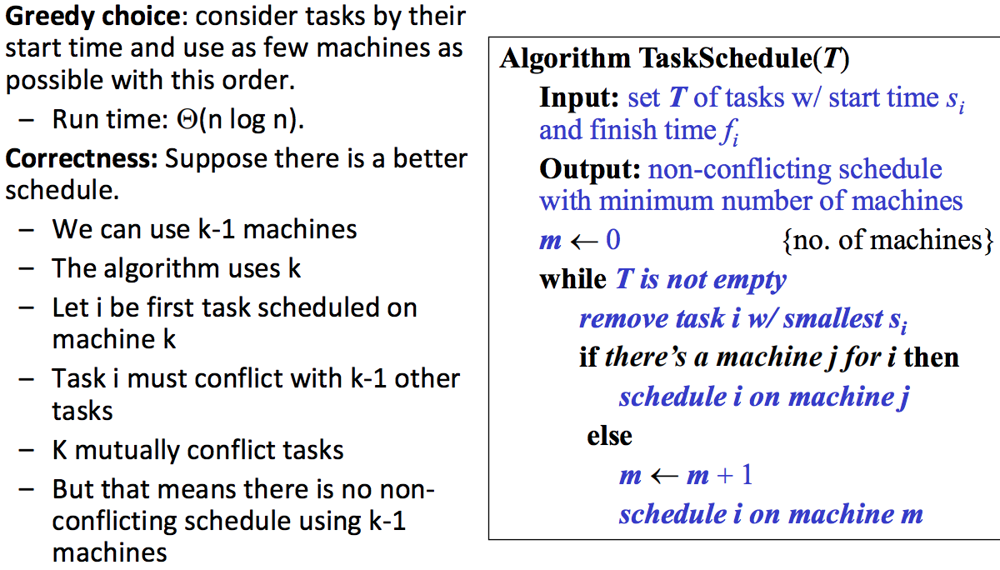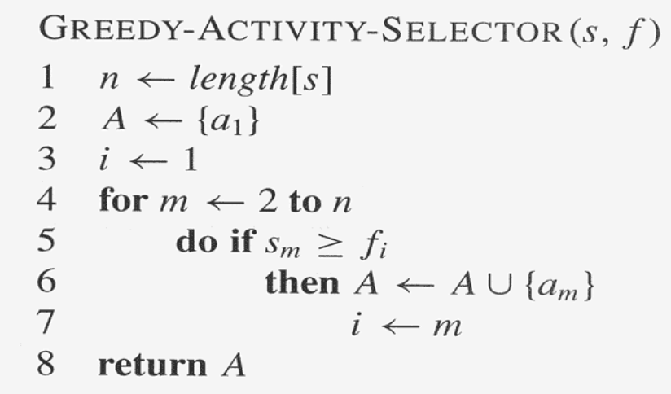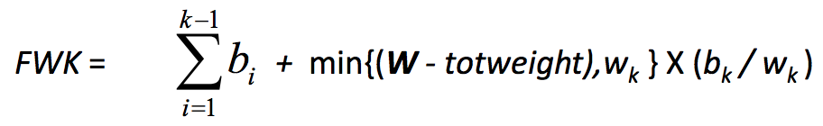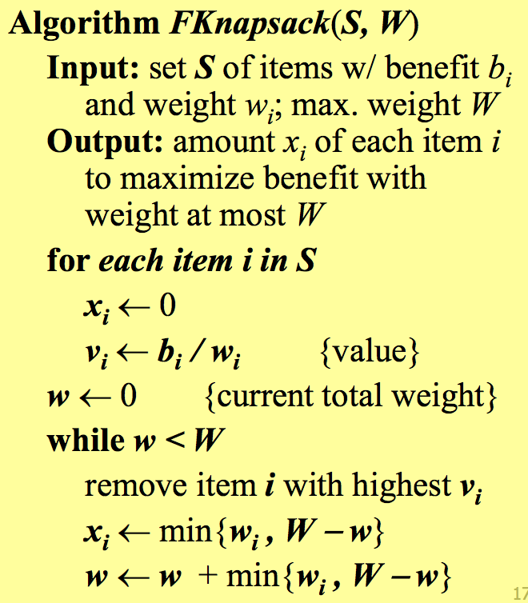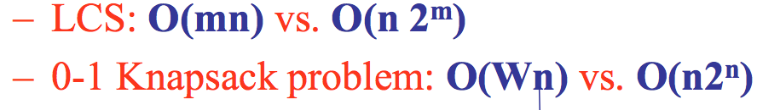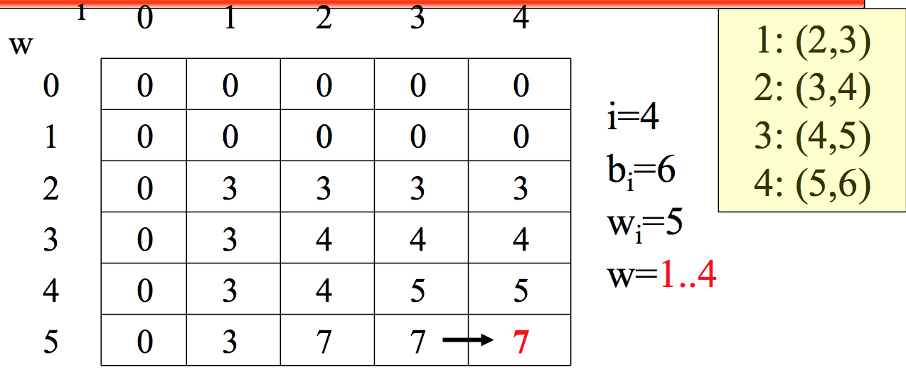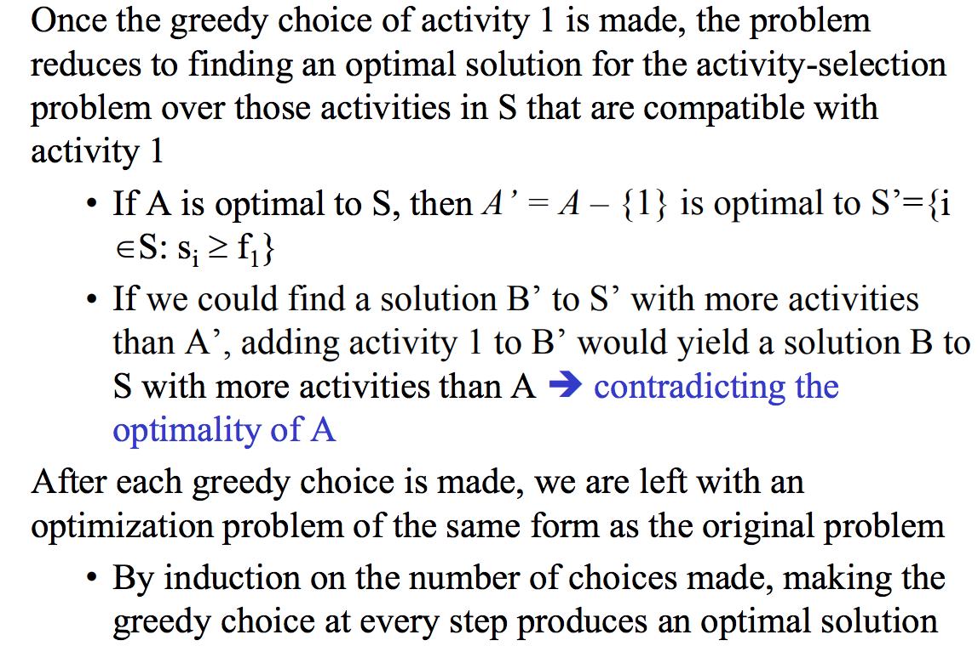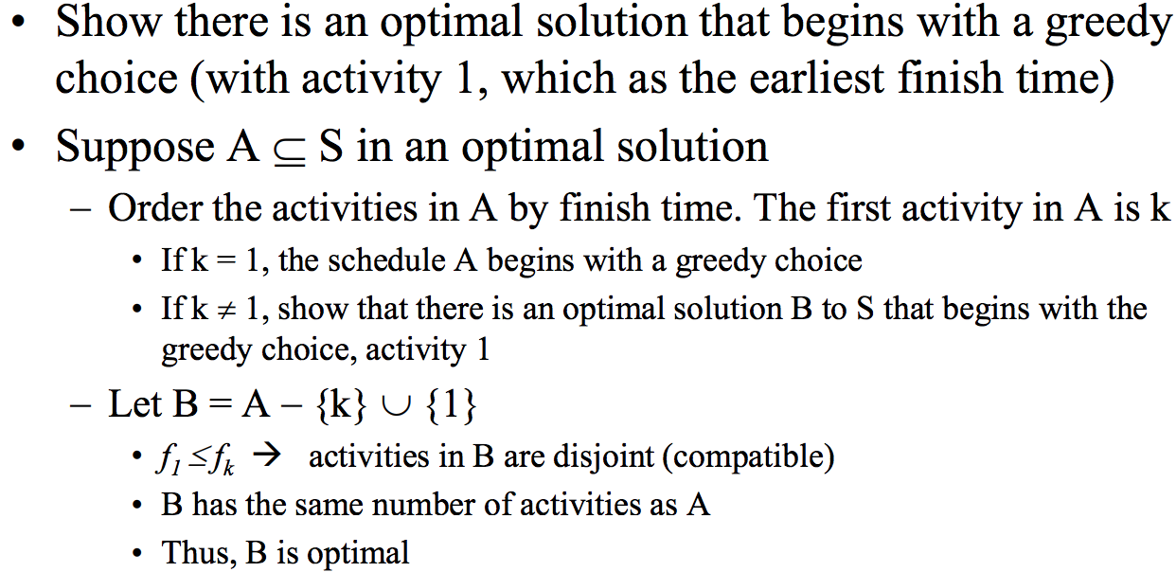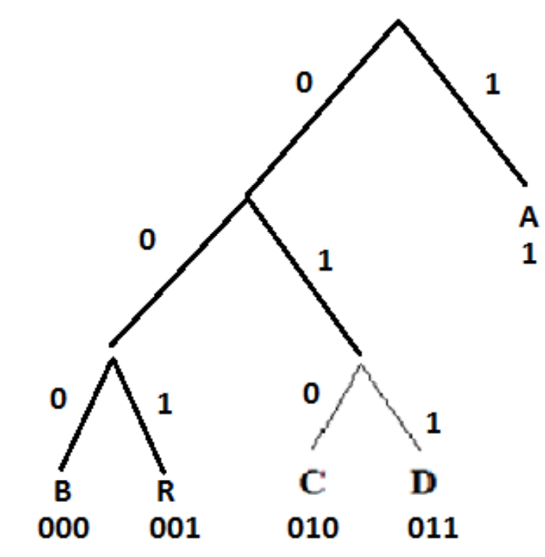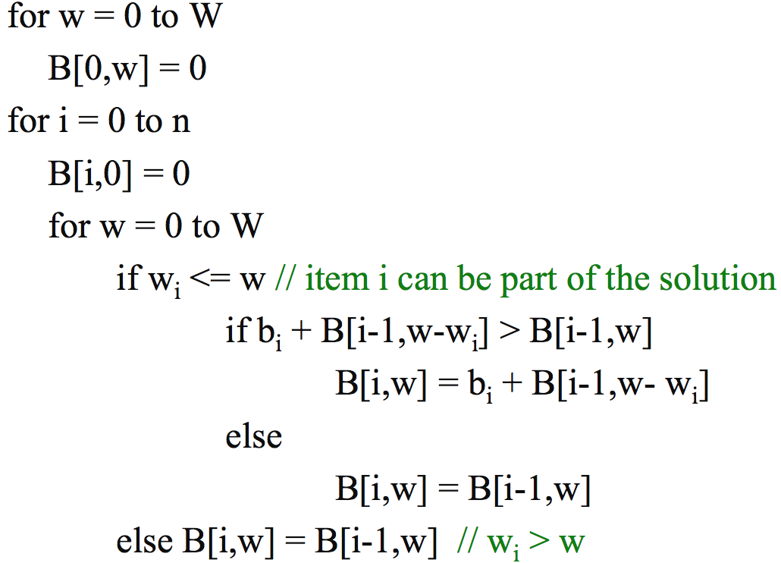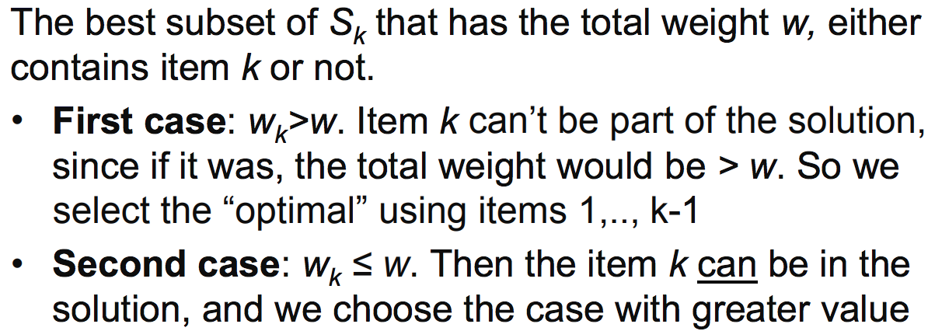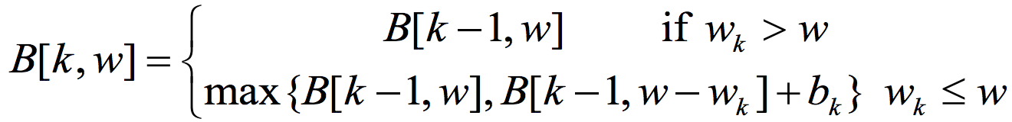

Practice Test

Proof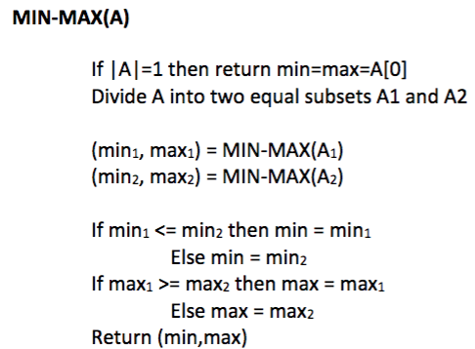

Modified rod(each cut now incurs fixed cost of c)

Bottom-up rod

Straight forward, top down, recursive

Coin change Algorithm(dynamic)

Rod cutting

Binary Search

MergeSort

Machine Scheduling

This is assuming the activities are already sorted by finish time. Runtime O(nlgn) because we have to sort. We look through our start times and find the start time that is > the finish time we just put in and add to our list.

Activity Scheduling (greedy)

Greedy-choice propertyproperty

Optimal substructures

Calculating value (vi = bi/wi) is theta(n). Sorting the items is theta(nlgn). Adding items to the knapsack is theta(n). Fill with fraction of last item if needed. Total is theta(nlgn).

Fractional Knapsack (greedy)

This algorithm finds the max value that can be carried in the knapsack. LCS to find the items used.

First set 0’s across the top and side(from the for loops at the top). Then, the first weight we can put in is a weight of 2 with a value of 3, put it in item 1. Now, the max value we can get with one item is 3 so fill it down.

Greedy Algorithms (proof)

You start with the smallest frequencies. Cannot have a prefix of another one. Idea based on a greedy approach

First for loop is O(W), we repeat n times, then second for loop is O(W). Therefore, the running time is **O(nW) pseudo-polynomial.** In comparison, brute-force takes O(n2^n) Better than brute force if W << 2^n

First case, it does’nt fit so we don’t use it. Second case, it fits now we decide if we want it, if we don’t we get the previous benefit we had without using it

0-1 Knapsack Algorithm

Huffman Code

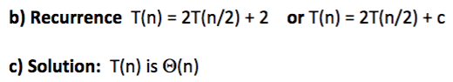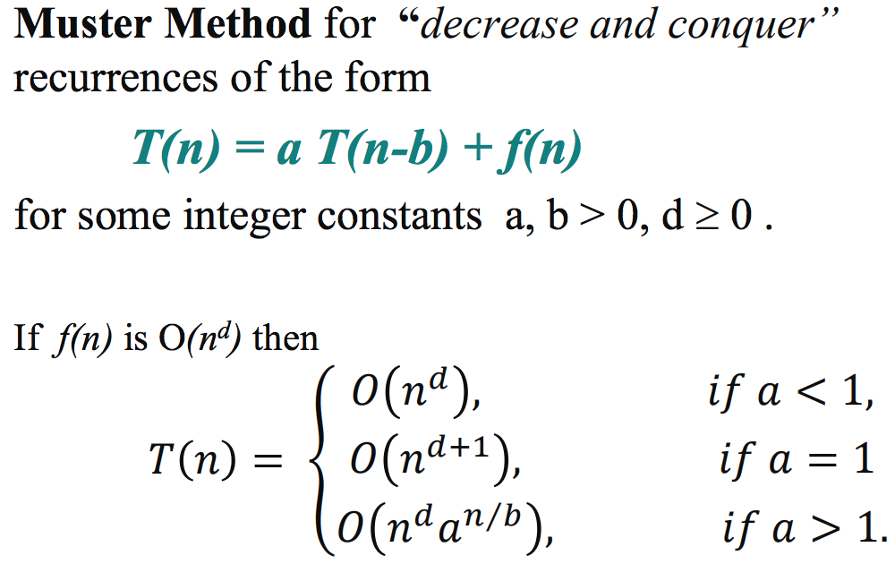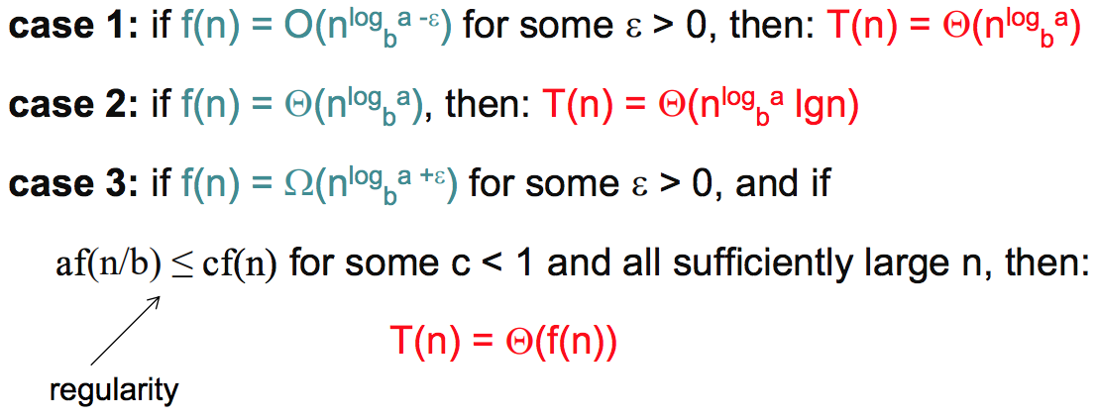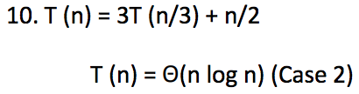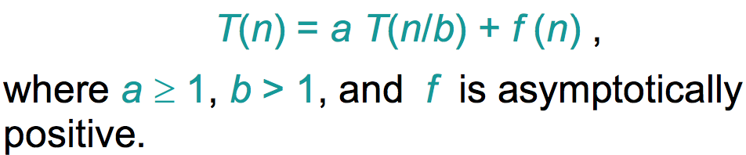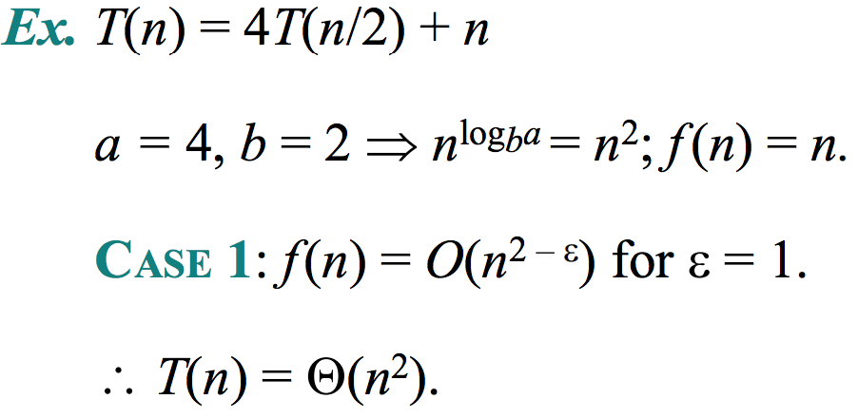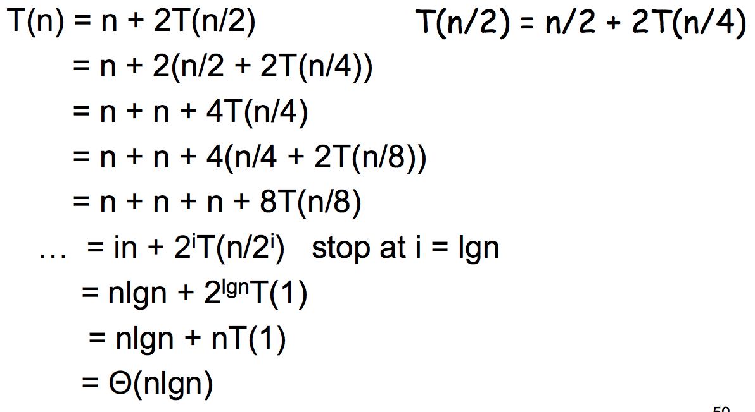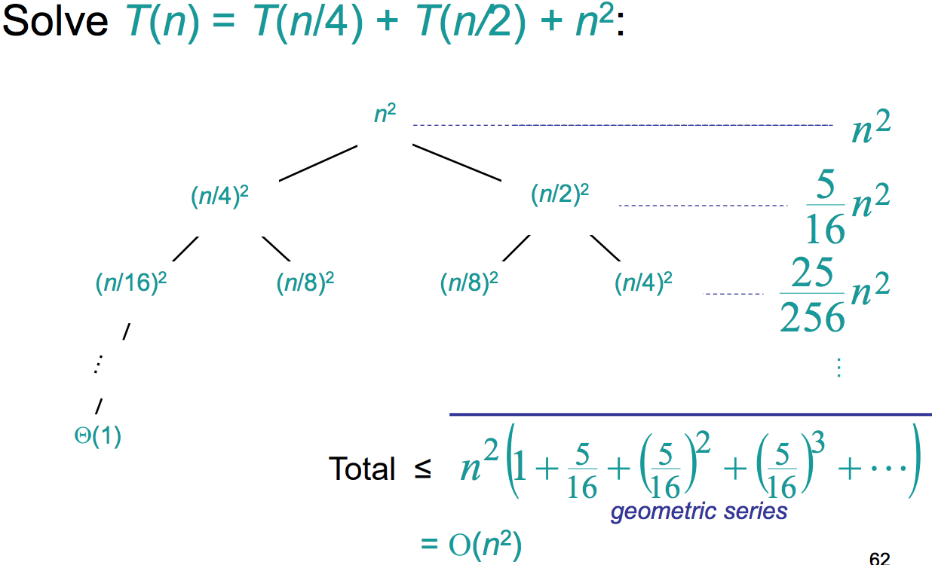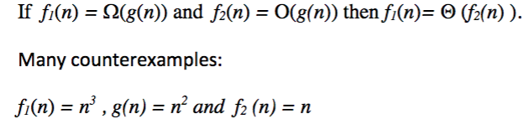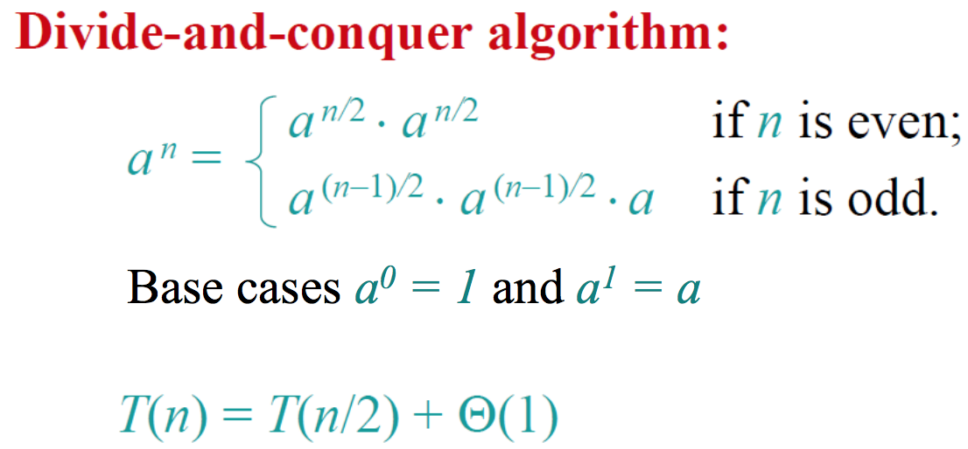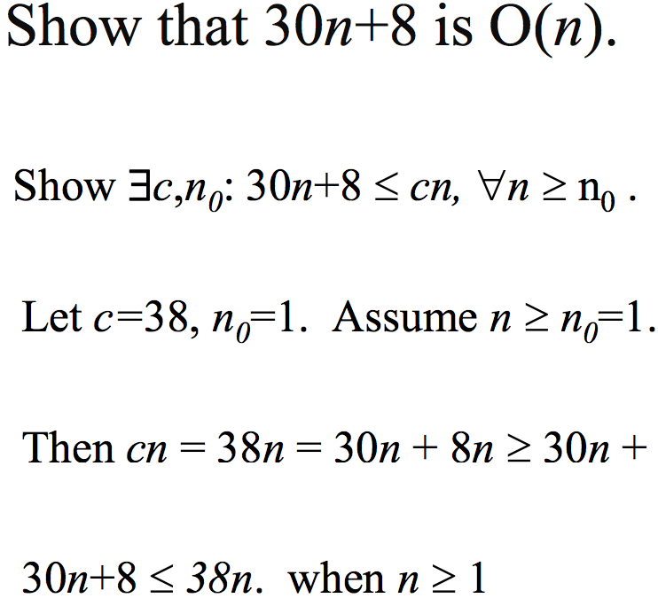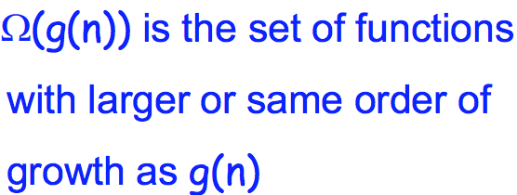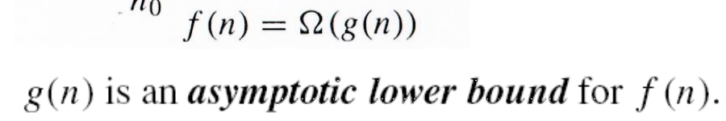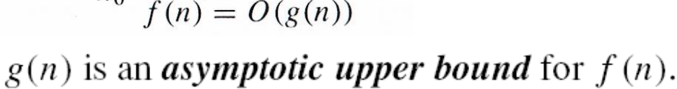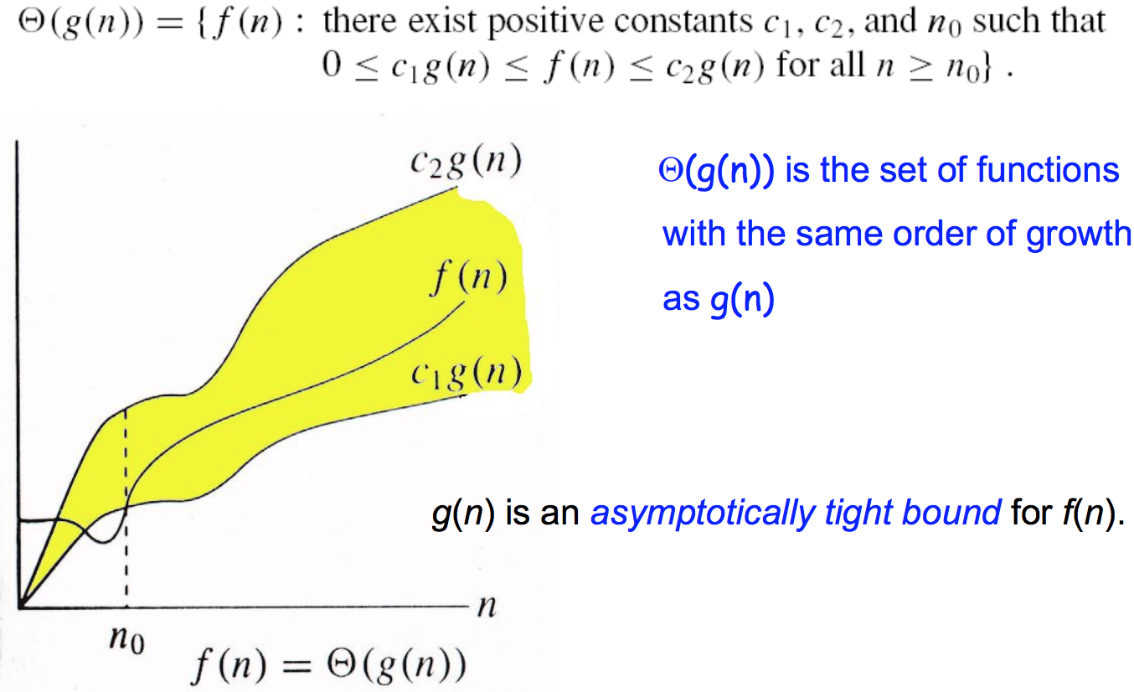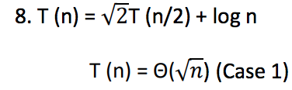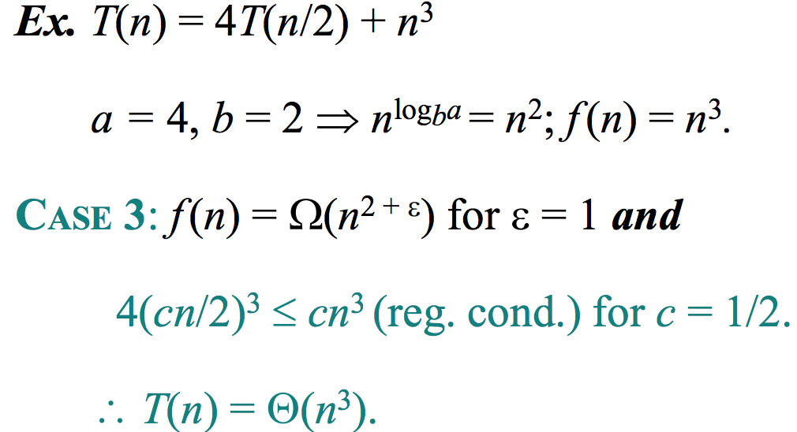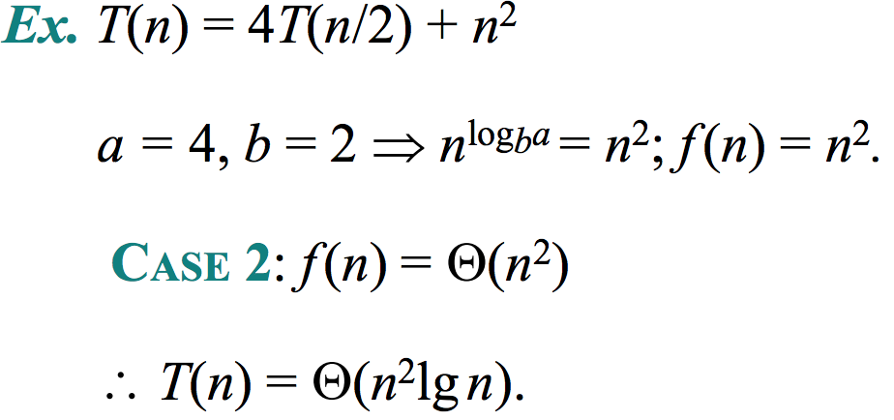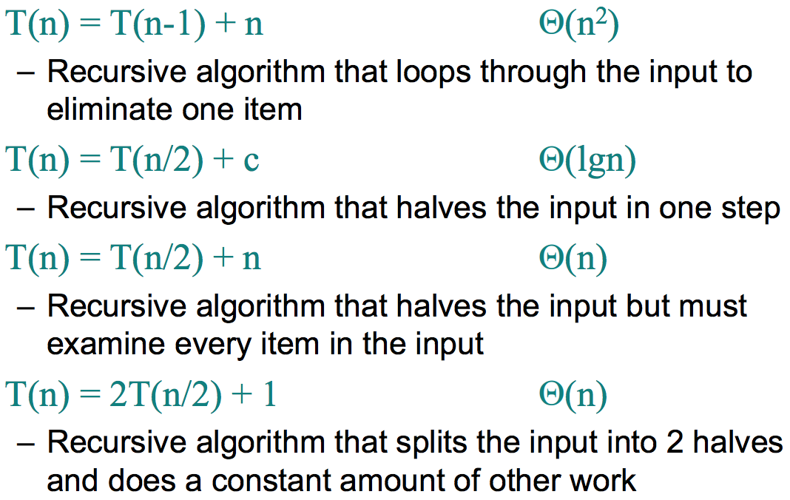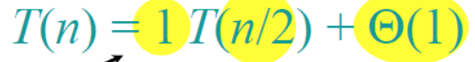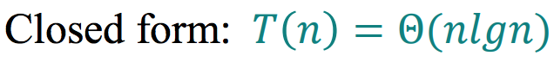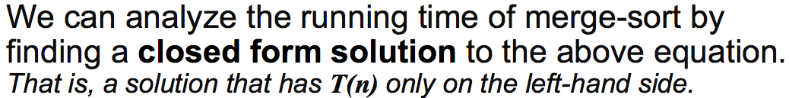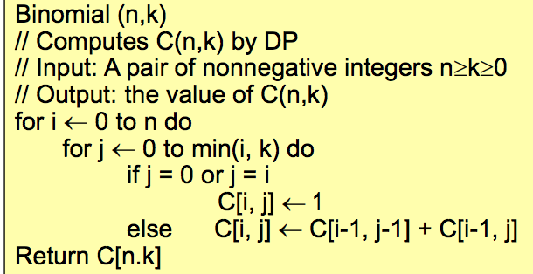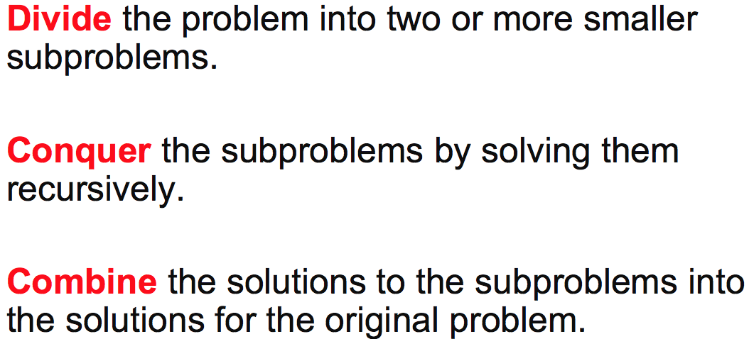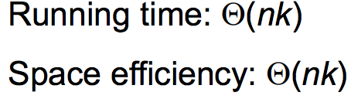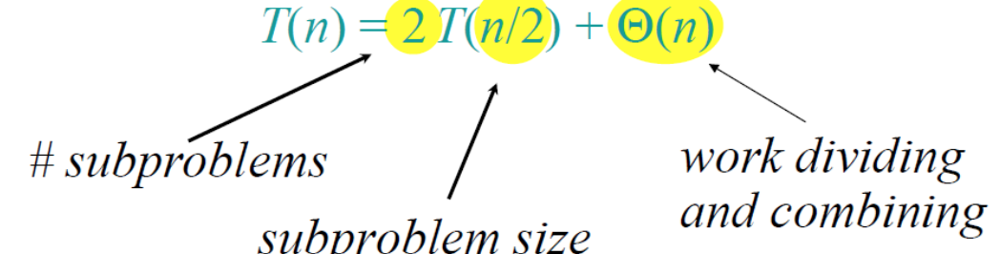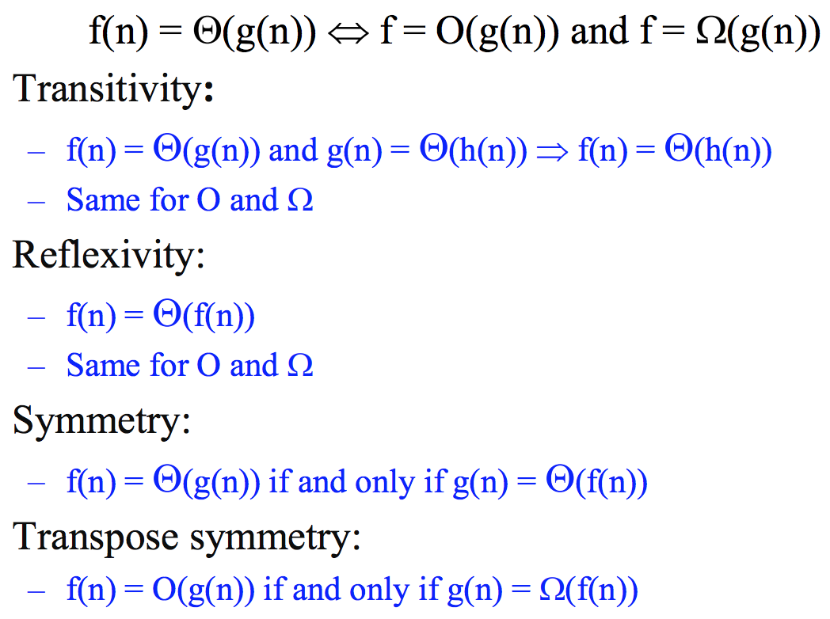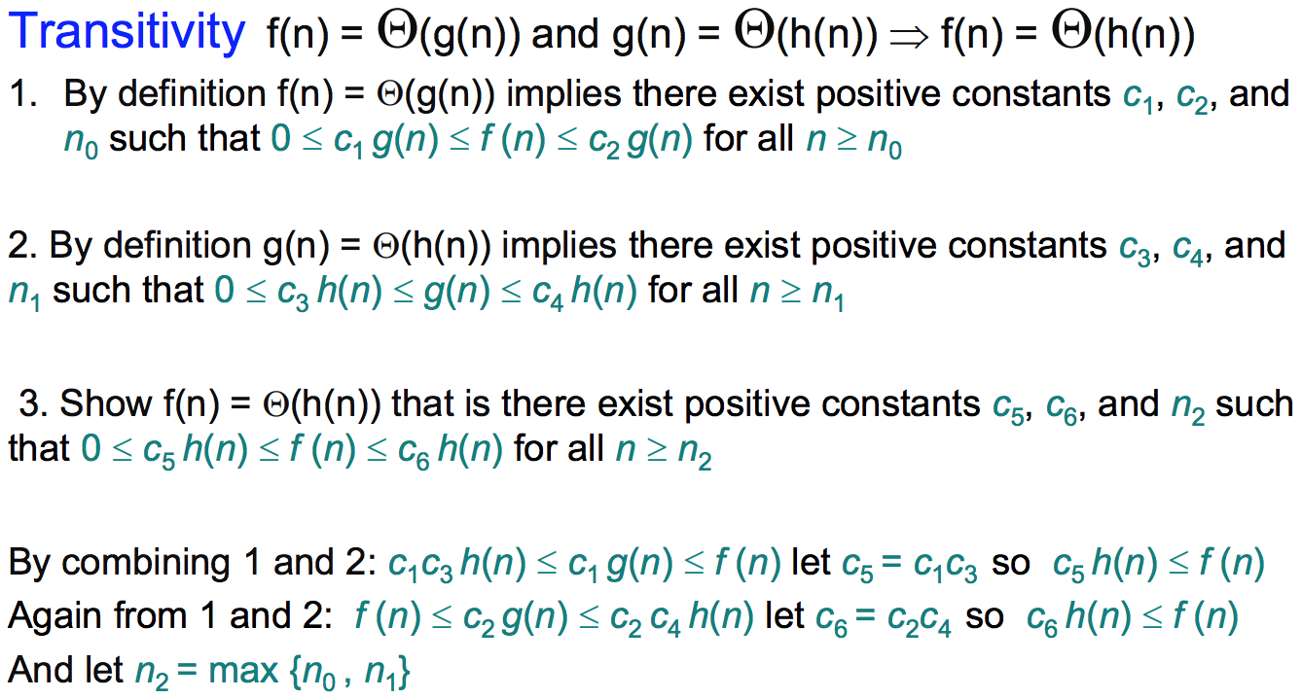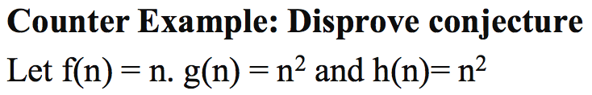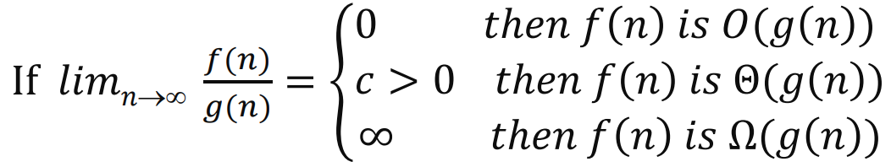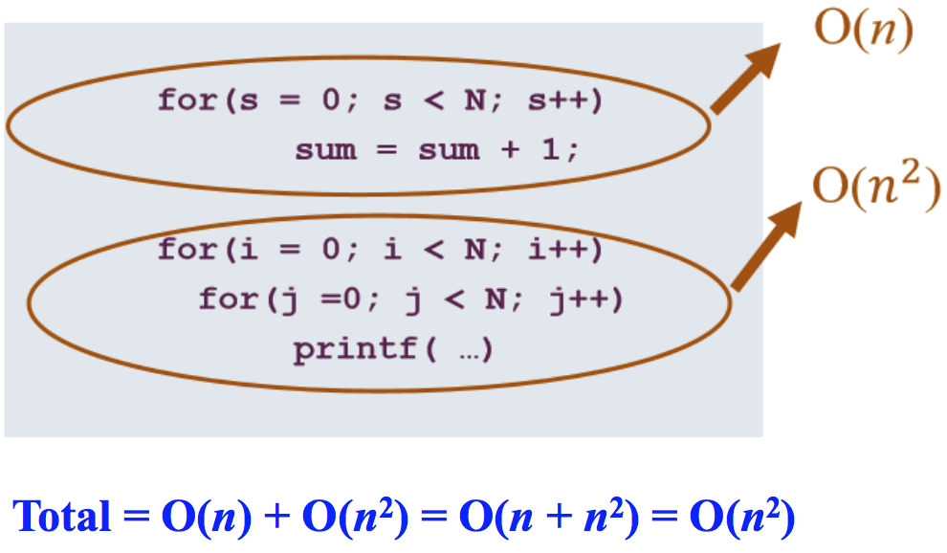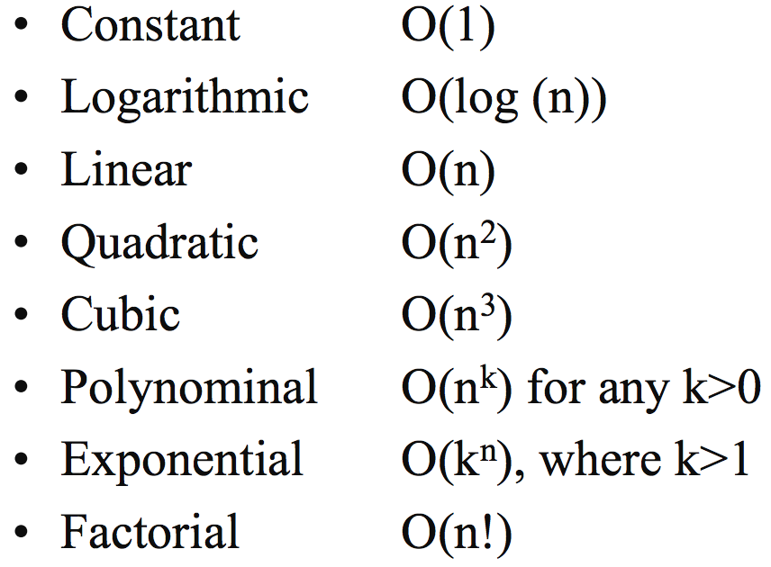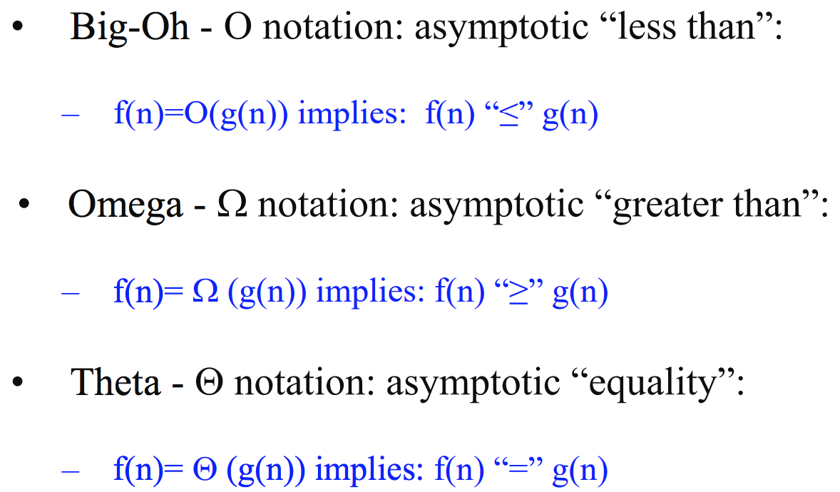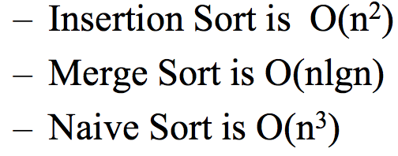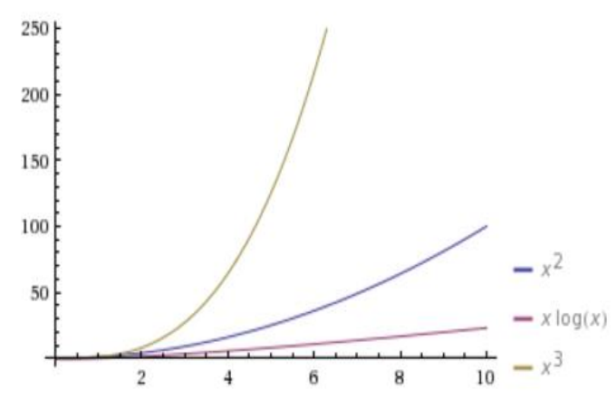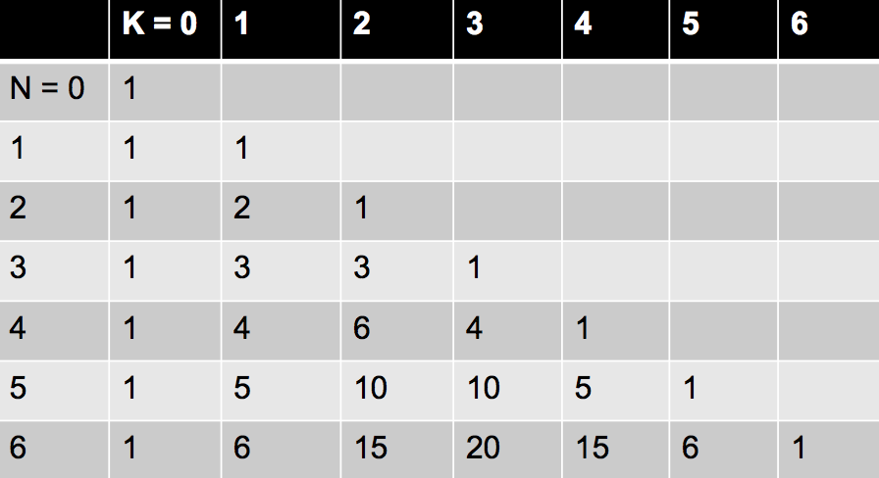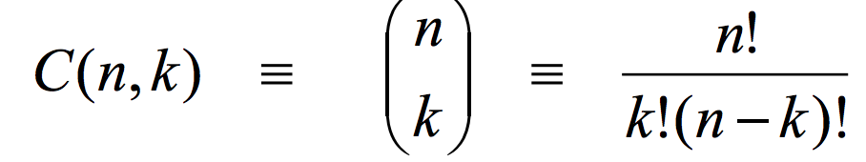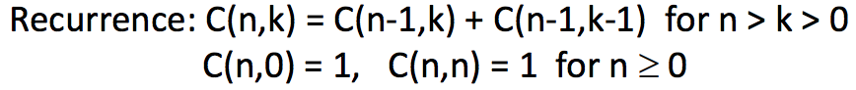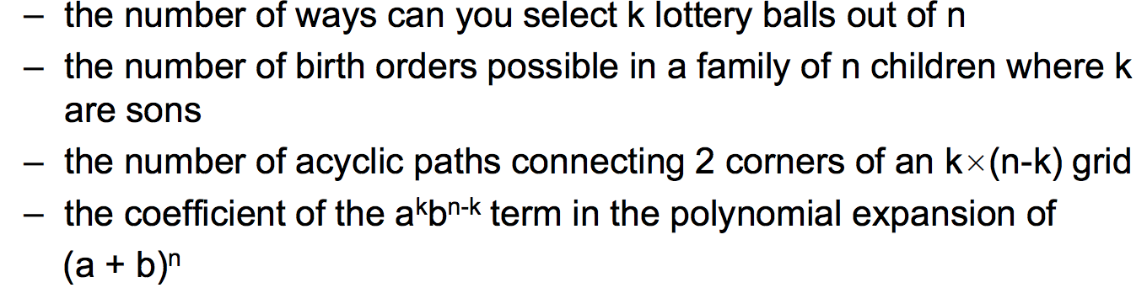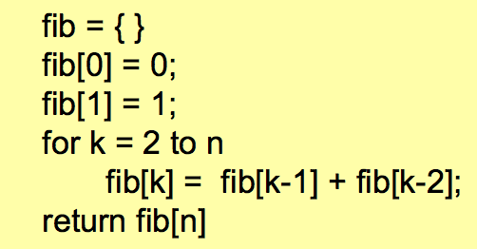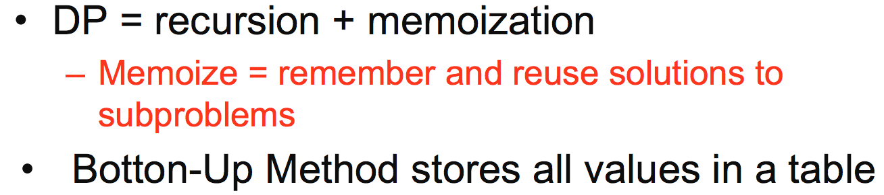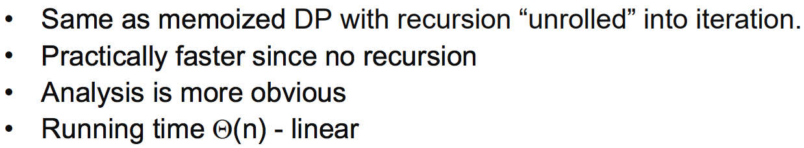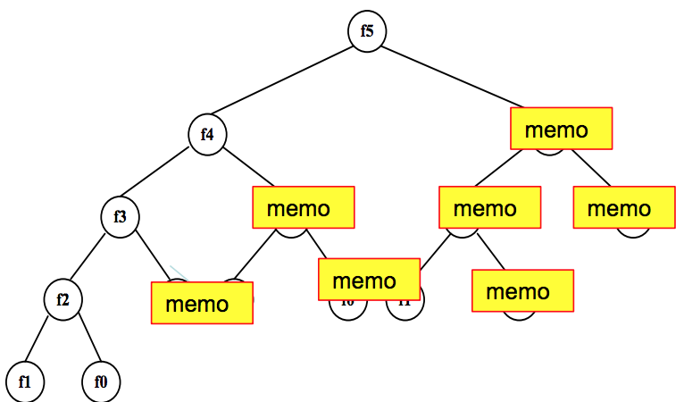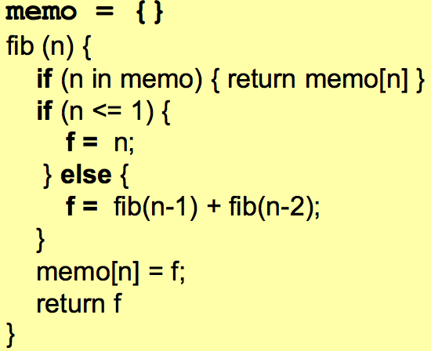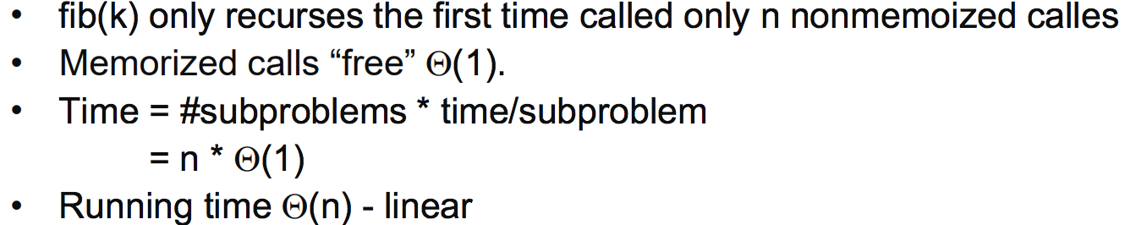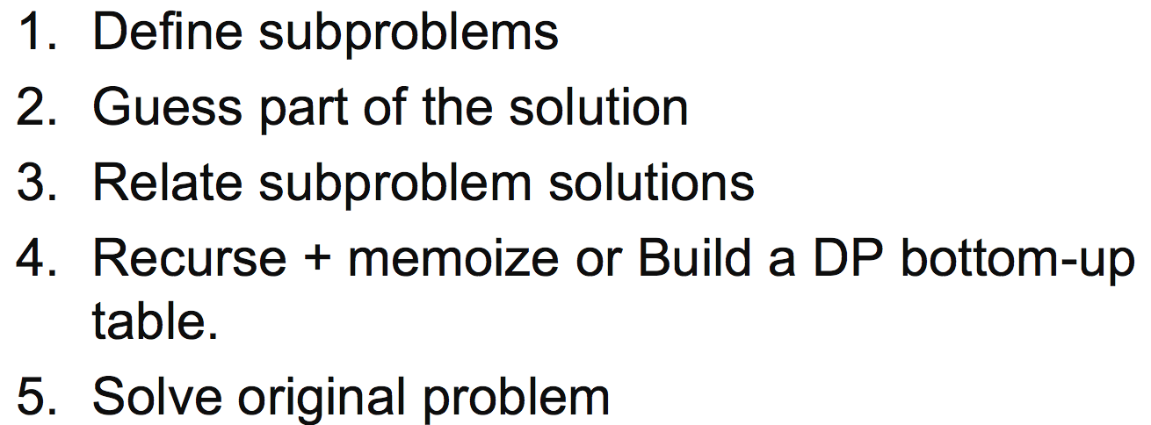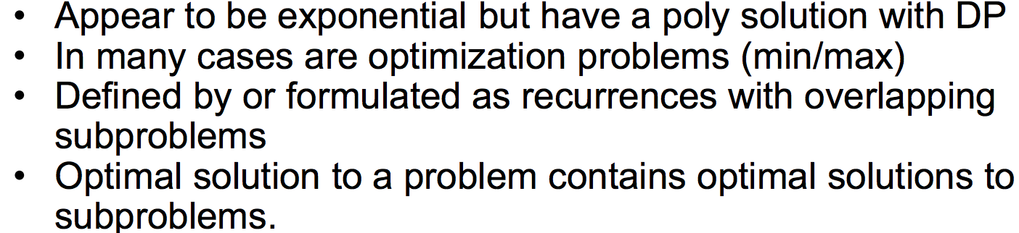

Divide-and- conquer min-max

NOTE: a must be a constant, 2^n is NOT a constant. f(n) must be positive. If its –n then it’s not.

Muster method

The dominant value here is $n^{3}$. $n^{2+E}$ means bounded below by $n^{2}$.

$\log_{b}a$ is $\log_{2}4$ = 2 so = $n^{2}$ which tells us that the # of leaves we have is $n^{2}$. Leaves are dominating with $n^{2}$ vs n so we go with the bigger one $n^{2}$. Bounded above. Running time is the one with T(n).

Case 2– weight is about the same

Case 3– weight decreases from root to leaves (root holds weight)

Case 1 – weight increases from root to leaves (leaves hold weight)

a and b have to be constants

Recursion tree

Counter example

Sqrt(n) goes in-between log and linear

Big-Oh – upper bound

Omega – lower bound

Theta – growing at the same rate

If you are theta you are both O and Omega

For the first one we can say that g(n) will either be the same or grow faster

Theta notation

If f and g both diverge on zero or infinity then apply l’Hopital Rule

Master method

Iteration Method - MergeSort

Second one is binary search

Recurrences Solutions

Power of a number

Binary Search: Find x 1) Check the middle element(if x -> done) 2)recursively search 1 array only(if x<middle element, search left array, same for other side.

Theta(1) for combining because we aren’t combining, only checking the center element so constant time

Binary Search

MergeSort

With DP we are concerned with **1)Size of table 2)Time it takes to fill(or calculate) each cell.** Size of table = n x k. Time to fill in each cell here is constant time(just adding them together).

**Ex:** C(49,6) 49=n ;6=k, so it’s pseudo-polynomial because we have another factor besides k. Largest k can be is n.

If we did it recursively, instead of using DP, it would have been O(2^n). Very slow.

Divide and Conquer

We do recurrences when an algorithm contains a recursive call. This is an example for MergeSort. Theta(n) is the same thing as C(n).

Proof

Properties

Limit method

**Worst case** (upper bound, guarantee that the algorithm wont run longer, no matter what input)

**Best case** (lower bound, input is the one for which the algorithm runs the fastest)

**Average case = Expected value** (prediction of running time, assumes the input is random)

Asymptotic Analysis

DP Algorithm Binomial Coefficient

Building the table with bottom-up method. Set all the 1’s and then add to get the other values. Ex: C(1,0) + C(1,1) = 1 + 1 = 2 which goes into C(2,1) and so on.

Normal

Binomial Coefficient/Combinations

Liner running time is only for the loop shown here. Different from memo, here we make the whole table assuming we are going to use everything. We just start filling the table as we go, completely iterative, we unrolled the recursion into iteration. Start at f(0), f(1), ect and store the values in the array.

Bottom-up DP Algorithm

If it’s not in the things we know then we need to calculate it and put it in the things we know and return the value. If it is, then we just use the value. Only store as you need them. Breaks out of recursion when it hits the memo part above.

Memoized DP Algorithm

Could be to find the shortest path or longest increasing sequence

Dynamic Programming